SFCM
Securities Finance Collateral Management

OTC Cleared FAQ - Mainline
Applies to Software Version: 5.8 (Mainline)

Ó Copyright Broadridge 2022. All Rights Reserved.
Unpublished rights reserved under applicable copyright and trade secret laws.
Broadridge Financial Solutions
2 Castle Terrace,
3rd Floor,
Edinburgh,
EH1 2EL

The contents, ideas and concepts presented herein are proprietary and confidential.
Duplication and or disclosure to others in whole or part is prohibited

Document History
Version | Author | Date | Comment
1.0 | Dan Griffiths | 26/05/2020 | Document created

Contents
OTC Cleared i
1 FAQ - Scope 1
2 Harmonised CCP data tables 3
2.1 Which CCP files does the module support? 3
2.2 What CCP data does the harmonised data tables support? 3
2.3 How are the different files loaded? 7
2.4 Can I feed in CCP files where some of the files are blank? 8
2.5 How can I check when the last complete batch was run? 8
2.6 Where can you see errors/ processed 9
2.7 Can I specify which CCP files are mandatory to complete the batch? 10
3 Static Data 11
3.1 How do I setup the relationship data? 11
3.1.1 How should the Client Clearing data look? 11
3.2 What Company static do I need setup? 13
3.2.1 How do I setup a new Company? 13
3.2.2 What delivery details do I need for my company? 14
3.3 What is the Profit Centre Management? 14
3.3.1 What profit centre books do I need to setup? 14
3.3.2 How do I create a Company in the hierarchy? 14
3.3.3 How do I create a Profit Centre in the hierarchy? 15
3.3.4 How do I create a Book in the hierarchy? 16
3.4 How do I give the user access to the CMS? 17
3.4.1 How do I create user access? 18
3.4.2 How do I assign the different CMS components to the user? 19
3.5 How do I setup client and CCP data? 21
3.5.1 Can I categorise different types of clients? 22
3.5.2 Can I add an external reference to the client data? 22
3.5.3 Can I group client data in a fund major/minor setup? 23
3.5.4 How do I setup client data? 24
3.5.5 How do I set the rate on the bank loans for client financing? 25
3.5.6 What additional static is needed for financing client intraday calls? 26
3.5.7 How do I set the SSI’s for the delivery of cash and non-cash collateral? 26
3.5.8 What additional CCP static data is required? 27
3.5.9 How do I assign clients to different regions or groups? 27
3.6 How do I setup the collateral eligibility and haircut static? 28
3.7 How does the module automate the authorisation of certain trade types? 28
3.8 Why do I need an Agreement Type? 29
3.8.1 Can I edit an Agreement Type? 30
3.8.2 Can I delete an Agreement Type? 30
3.8.3 Can I store multiple collateral sender email addresses? 31
3.9 How do I setup new collateral agreements? 31
3.9.1 Can I store multiple client email addresses? 33
3.10 How do I approve static data? 33
3.11 Can I view the audit of static data entries? 34
4 Workflow 35
4.1 How is the margin call field calculated? 35
4.2 How are the bank loans cancelled? 35

FAQ - Scope
Central Counterparty Clearing, or otherwise known as CCP’s is a financial institution that takes on the counterparty risk of OTC Derivatives contracts. The business line ‘OTC Cleared’ is where derivatives contracts are transacted bilaterally, the agreed contract is then novated to the CCP for clearing and settlement, the CCP has stepped in between both parties of the contract.
Due to CCP liquidation practises member firms require sizable capital requirements in order to support the CCP in time of market stress. As a result of the member firm responsibilities, buy side participants will use a clearing broker/FCM to clear their derivatives contracts.
SFCM’s Collateral Manager (CMS) supports the business line ‘OTC Cleared’ and is the post-trade risk management process around the collateral management activities associated with CCP’s. The method supported within the module is:

- Client Clearing (acting as broker/FCM)

The module offers integrated front to back office functionality for OTC Cleared and includes exposure management, centralised inventory, asset selection, collateral approval, automated reporting, corporate actions, swift and settlements.
The CMS receives margin reports daily from the CCP/Clearing Broker/FCM to consume and calculate the different margin requirements. During this process the module will supplement the CCP data with SFCM’s own data to provide a complete view of exposure and collateral.
The CMS uses Broadridge’s Message Automation to consume the margin reports from CCP’s/Carry Brokers/FCM’s as a single interface. Alternatively, SFCM can interface to any number of CCP’s to consume collateral reports.
The different types supported as part of the Client Clearing method are:

- Individually Segregated Accounts (ISA)
- ISA Direct
- Omnibus Segregated Accounts (OSA)
While the different margin types that are supported are:

- Initial Margin
- Variation Margin
- Intraday Call
- Broker Buffer
Initial Margin is the amount of collateral required for the open derivatives positions calculated by the central counterparty. This is based on the Value at Risk (VAR) calculation and required to pledge by the client to the central counterparty (CCP).

Variation Margin is a variable margin payment made by the CCP to reduce the exposure. The payment and receipts are settled daily and contains the following components:

- NPV delta
- Coupon
- Price Alignment Interest (PAI)
- Upfront/Settlement Fees

Intraday Call are margin calls made by the CCP during the day when there is insufficient collateral in the client’s clearing account.
Broker Buffer is where additional collateral is calculated and requested from the clearing broker/FCM in order to reduce their risk to the clients.

Harmonised CCP data tables
The data reported by the CCP is the source of valuations and consuming different CCP data is essential to the clearing requirements. Each CCP may represent data in different ways and as a result our data model has been made flexible to support multiple CCP feeds.

Which CCP files does the module support?
The CMS supports the feed of CCP margin reports by interfacing with the harmonised data tables. Clients can interface with the harmonised data tables with many different CCP’s and in different formats.
The following are the file types supported.

File Type | Harmonised Table
Initial Margin | al_ocm_im
Cash Collateral Breakdown | al_ocm_ccb
Non-Cash Collateral Breakdown | al_ocm_nccb
Variation Margin | al_ocm_vm
Intraday Call | al_ocm_icf
CCP FX Rates | al_ocm_fxrate

What CCP data does the harmonised data tables support?
The following are the data types supported for the different file types.

IM Data File | Description
Timestamp | The time and date reported in the margin reports.
CCP | The CCP from the margin reports and maps to the CMS agreements.
Broker
Client Account | The clearing account stored in the margin reports. This may be the account at the CCP, Clearing Broker or FCM and is used to map to the CMS agreements.
Currency | The currency of the Total Required IM as reported by the CCP.
Total Reqired IM | The total IM requirement/exposure at the CCP.
Account Type | For Client Clearing only. Supports the need to load different sets of CCP files at different times.  C = Client  H = House

CCB Data File | Description
Timestamp | The time and date reported in the margin reports.
CCP | The CCP from the margin reports and maps to the CMS agreements.
Broker
Client Account | The clearing account stored on the margin reports. This may be the account at the CCP, Clearing Broker or FCM and is used to map to the CMS agreements.
Currency | The currency of the cash balance at the CCP.
Price | The price applied to the cash value.
Cash Value | The value of cash before a haircut has been applied to the cover value.
Haircut | A discount value applied to the cash posted at the CCP.
Collateral Value | The collateral value applied to the Total Required IM.
Account Type | For Client Clearing only. Supports the need to load different sets of CCP files at different times.  C = Client  H = House

NCCB Data File | Description
Timestamp | The time and date reported in the margin reports.
CCP | The CCP from the margin reports and maps to the CMS agreements.
Broker
Client Account | The clearing account stored on the margin reports. This may be the account at the CCP, Clearing Broker or FCM and is used to map to the CMS agreements.
Currency | The currency of the cash balance at the CCP.
Security Code | The identifier of the security reported by the CCP in the margin reports. This will be cross referenced against the security static stored within SFCM.
Quantity | The quantity of settled collateral at the CCP.
Price | The price of the security as reported in the margin reports by the CCP.
Haircut | The discount applied by the CCP to the market value of the non-cash collateral.
Collateral Value | The collateral value applied to the Total Required IM.
Account Type | For Client Clearing only. Supports the need to load different sets of CCP files at different times.  C = Client  H = House

VM Data File | Description
Timestamp | The time and date reported in the margin reports.
CCP | The CCP from the margin reports and maps to the CMS agreements.
Broker
Client Account | The clearing account stored on the margin reports. This may be the account at the CCP, Clearing Broker or FCM and is used to map to the CMS agreements.
Sub Account | The sub account only applies to VM records and stored on the margin reports. This is the account at the CCP and used to map to the CMS agreements.
Currency | The currency of the cash balance at the CCP.
Total VM Movement | The total of all components reported in the margin report for today.
Product Type | The asset type of the cleared derivative i.e. IRS.
Trade Reference | The reference of the derivatives trade.
NPV COB T-2 | The NPV from COB T-2 and used to calculate the NPV delta used for the margin requirements.
NPV COB T-1 | The NPV from COB T-1 and used to calculate the NPV delta used for the margin requirements.
NPV Delta | The change in NPV from COB T-2 and T-1. Information only.
PAI | The price alignment interest calculated on yesterday’s NPV delta.
Coupon | As reported by the CCP.
Upfront Fees | The settlement fees associated to the derivatives trade which is being cleared by the CCP.
Broker Fees | The fees applied and reported by the clearing broker/FCM.
CCP Fees | The fees applied and reported by the CCP.
Monthly Interest | Interest accruals reported on cash balances at the CCP.
Account Type | For Client Clearing only. Supports the need to load different sets of CCP files at different times.  C = Client  H = House

How are the different files loaded?
CCP data is fed in through the DTL, this interprets each file using a specific translation class. The DTL will process the externally fed CCP data files in the respective AL_EXT tables.
The CCP File Monitor Table signals to the engine that a complete set of CCP data is ready for processing.
The IM, CCB, NCCB and VM files are grouped into batches and processed together into margin call envelopes. The file monitor table contains a history of all files in all batches which have been loaded, this includes the batch status.
Only once all files have been loaded will the data be published in the CMS.

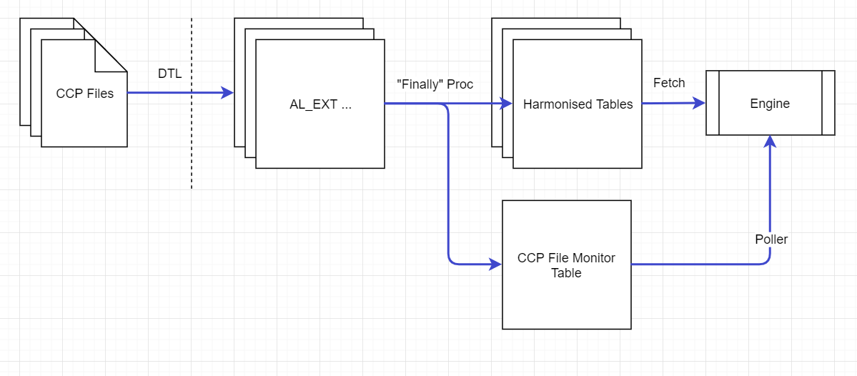
The FX Rates and Intraday Call Files are processed individually and not part of a batch.
CCP FX Rates must be loaded prior to the CCP margin reports.

Can I feed in CCP files where some of the files are blank?
The CCP files may genuinely have no data, more commonly in the CCB and NCCB files.
It is mandatory to include at least one row of data in the IM and VM files.
The CCB and NCCB files can contain no rows of data, but the empty files must be loaded with the existing headers for the CCP File Monitor to deem the batch complete.

How can I check when the last complete batch was run?
To check the date of the last batch successfully processed use the following query. The results will display all the batches grouped by CCP and Account Type.
select * from al_cm_ccp_batch;
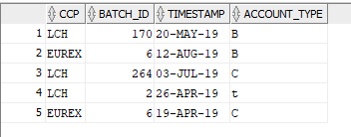
For the batch to be complete all files (IM, CCB, NCCB and VM) as part of the batch process must be successfully processed. There will be 4 records in the following table with the same Batch Id and Ready
select * from AL_CM_CCP_FILE_MONITOR order by batch_id desc, insert_date desc;
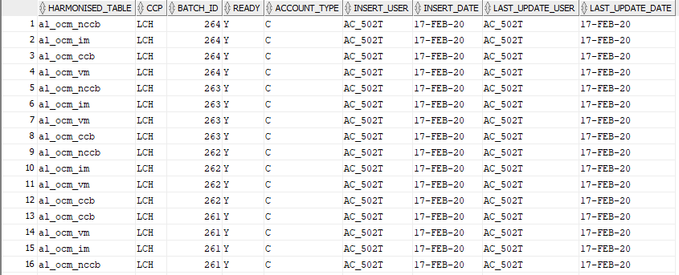

Where can you see errors/ processed
If the data is accepted it will be enriched and written to the internal harmonised tables. If rejected it can be checked in the Gateway Error Viewer.
The feeds to check are:

- Initial Margin
- Cash Collateral Breakdown
- Non Cash Collateral Breakdown
- Variation Margin
- FX Rates
- Intraday Call File
The batch files (IM, CCB, NCCB and VM) cannot be reprocessed through the Gateway Error Viewer, but instead the rejected records must be reloaded again and as a batch but only for the rejected records. Alternatively reloading the full set of files will add new records and update the existing complete margin calls, but only where they remain in the opening workflow state.

Can I specify which CCP files are mandatory to complete the batch?
At the implementation stages of the delivery SFCM can configure any changes necessary to the feeding of CCP data and how the CCP File Monitor handles the different files from the CCP.
The table AL_CM_CCP_XREF will manage the configuration.
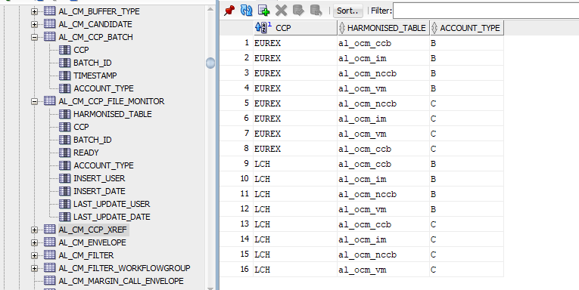

Static Data
There is some static data required before the user can progress with the full capabilities of the Collateral Manager (CMS).
The following is a guide to the setup:

# | Task Ordering | Application
1 | Company | Main
2 | Profit Centre Management | Main
3 | User Permissions | Main
4 | Clients | Main
5 | CCPs | Main
6 | Collateral Schedules | Xpose
7 | Trade Authorisation | Main
8 | Agreement Types | CMS
9 | Agreements | CMS
10 | Static Authorisation Module | Main
For details on each area of the setup please see sections below.

How do I setup the relationship data?
When creating relationship data in SFCM it is important to have it structured as it is represented in the real world, and this then allows the data flows to be consistent with the actual daily flows.

How should the Client Clearing data look?

# | Type | Description
1 | Company | The company is the clearing broker/FCM and is the entity facing both the CCP and investor.  All cash direct debits made by the CCPs are done between the company. All cash posted by the client is done between the company.  The non-cash collateral posted by the client to the CCP will pass through the company, as a result the Trading Book associated to the agreement will represent the company.
2 | Principal Client | The principal is the investor, the client clearing derivatives contracts.
3 | Counterparty Client | The counterparty in this relationship is the CCP.
4 | Agreement Type | The Client Clearing must be selected and the account type that mirrors the CCP setup (ISA, ISA Direct, OSA). Selecting the correct Agreement Type will mirror the daily flows.
5 | Trading Book | The Trading Book represents the Company.  The non-cash collateral posted by the client to the CCP will pass through (ISA, OSA only) the company.  In addition, cash posted to the clearing broker will be made to the company.
6 | Tracking Book | The Tracking Book represents the Principal client, otherwise known as a tracking client in SFCM. In order to become a tracking client, the book is linked to the client data. This is required for collateral bookings and can represent the client external availability if available.

What Company static do I need setup?
The main Company in the hierarchy is created when the system is installed at the site of the users. The main company will represent the investment company at the top level or the parent company of a global organisation, following this sub-companies can be created that may represent other entities within the company structure. When creating sub-companies then all collateral agreement related client data must be created under the same company.
The main Company in the client hierarchy will also be the main Company in the Profit Centre hierarchy.

How do I setup a new Company?
Select Administration>Static Maintenance>Miscellaneous>Company from the Main Menu and you can select the existing top-level company or add a new sub company to the hierarchy.

Name | Type | Description
Company Code | Mandatory | The company code
Currency | Mandatory | The trading currency of the company
Country | Mandatory | The country of the company
Primary Company Code | Mandatory
Address | Mandatory | The address of the company, this is used on the reporting sent out from the CMS.

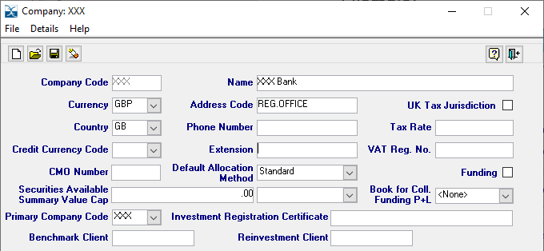

What delivery details do I need for my company?

Banks – refer to Swift Cash FAQ
Depot
Agent Selection Weightings
Bank Selection
Depot Selection

What is the Profit Centre Management?
The Profit Centre Management is a tool to create a hierarchy around securities financing and collateral trading activities. A profit centre may represent a trading desk as part of a legal entity (the London desk, New York desk etc). Another example is the profit centre allows you to group entities together like the master agreement/umbrella fund structures. The fund major (profit centre) represents the legal entity trading with the counterparties and the fund minor (book) acting as the underlying umbrella funds holding the assets. Depending on your structure a position could be made up of different trading activities i.e. firm positions, collateral, repo, stock loan etc.
In respect to Client Clearing the profit centre represents an entity that reflects the activities between the client and clearing broker/FCM.

What profit centre books do I need to setup?
For the purpose of the Client Clearing a Client Book (known as a tracking book) must be created to represent the client side of the relationship. A Trading Book is also required, this represents the clearing broker/FCM where the collateral is passed through and onto the CCP. This will also be the trading book used to support the financing of client shortfalls.

How do I create a Company in the hierarchy?
The top-level company will also be your top-level profit centre company, you can add more sub-companies to your structure.
The following is required when creating a new company.

Name | Type | Description
Type | Mandatory | Select Company
Code | Mandatory | Select the company from the options, these are the companies added in the Company static.
Name | Mandatory | This defaults to the company name and can be updated if required.
Currency | Mandatory | The currency of the company

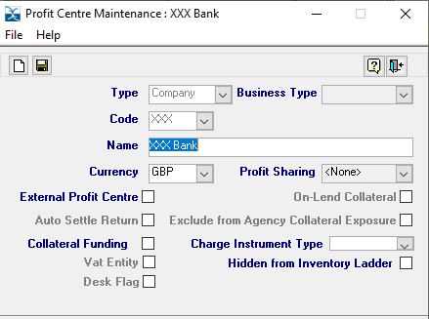

How do I create a Profit Centre in the hierarchy?
The next level will be a Profit Centre under one of the companies, this is a grouping feature.
The following is required when creating a new profit centre.

Name | Type | Description
Type | Mandatory | Select Profit Centre
Code | Mandatory | Create a new profit centre code
Name | Mandatory | Create a new profit centre name
Currency | Mandatory | The currency of the profit centre, this may be the same as the company.

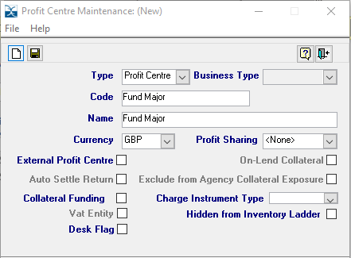

How do I create a Book in the hierarchy?
The next level will be a Book under one of the profit centres already added to the hierarchy.

The following is required when creating a new book.

Name | Type | Description
Type | Mandatory | Select Book
Business Type | Mandatory | Select Firm Financing when you are creating a Trading Book or Target Book when creating a Tracking Book.
Code | Mandatory | Create a new book code
Name | Mandatory | Create a new book name
Currency | Mandatory | The currency of the book, this may be the same as the company/profit centre.
The following is an example of the tracking book.
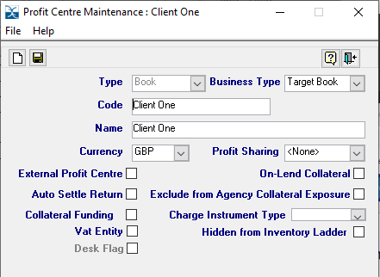
The following is an example of the trading book.
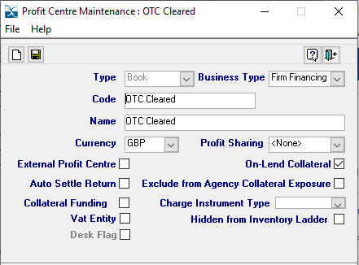
The following is an example of the profit centre structure.
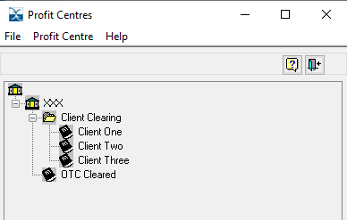

How do I give the user access to the CMS?
The business can configure the varied permission levels given to each user and this is done in the Security section of the static data.
Select Administration>Security and you will find the Users and Groups window to custom your user permissions.

How do I create user access?
There are 3 areas you need to consider when providing user access to the CMS functionality:

- Company Access and Segregation
- Trading Books
- Allowed Trading Status

- The user must have access to the Company Code to have permission to view the margin call data. The top-level entity of the agreements is set at the company level therefore provides segregation of data across users. Mark the companies the user can have access.
- Access to the trading books is required for the user to book cash payments and collateral movements. These trading books are also mapped to the agreements static.
- Finally, in order to approve candidates through the Asset Selection Module the user requires the Allowed Trading Status to be ticked for Unverified only. However, manual trade status changes made through the Trade Enquiry Window will require Pending and Settled status.
The following field are available to the user accessing the CMS.

Name | Type | Description
User Code | Mandatory | The user code for the user
Username | Optional | The name of the user
Unverified | Optional | Sets whether the user can create unverified collateral and highlighted above in point 3.
ending | Optional | Determines whether the user can manually verify collateral in the Trade Enquiry Window.
Settled | Optional | Determines whether the user can manually settle collateral in the Trade Enquiry Window.
Password Never Expires | Optional | Ticked for password not to expire, however the Oracle settings must be also set to this.
Default Location | Mandatory | The location of the user
Access All Companies | Optional | Determines whether the user can view data across all companies
Company Code | Optional | The companies the user can access and highlighted above in point 1
Access | Optional | Determines whether the user can access the data in this company
Verify Flag | Optional | Determines whether the user can verify collateral in this company.  The scheme user must have the verification flag set appropriately for the medium codes set up in Trade Authorisation to work. Medium codes are created to help configure the processes within the module.
Validate 4Nett | Optional | Sets whether the user is permitted to net and verify movements in the Cash Netting Module.
Book | Optional | Sets permission to the trading book and discussed above in point 2.

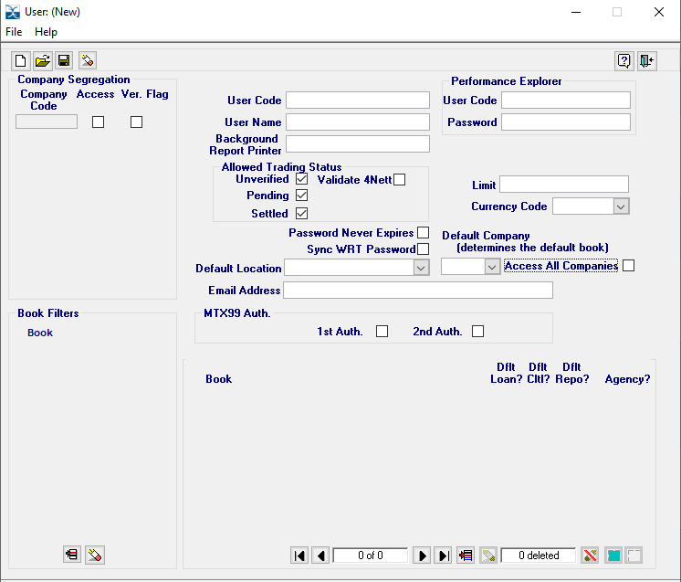
For more details please refer to the User Access FAQ.

How do I assign the different CMS components to the user?
The Groups allow the business to define different levels of privileges, one group may have supervisor permissions whereas another may have the basic admin rights. Alternatively, the business may have offshore offices where users do not have permission to enter collateral and need to have greater control some areas.
A security group must be created, this acts as a mechanism to associate a group of users to different objects (components/modules). Each object can have different levels of access; read, write and delete.
Add a new group to the window and select Users from the Details menu to assign the different users to the group. Users can be removed from a group at any stage.
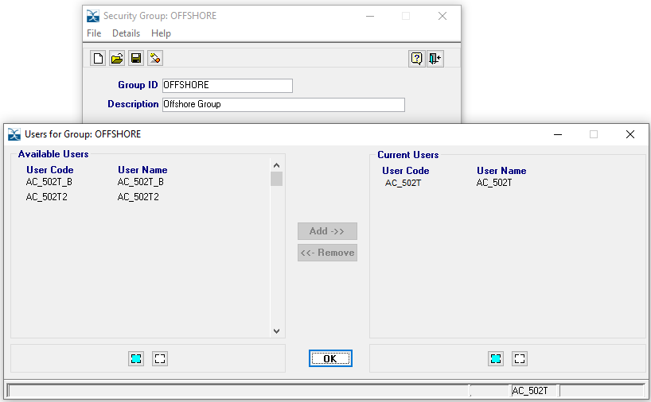
Now you can assign the different objects to the security group by selecting the Rights from the Details menu.
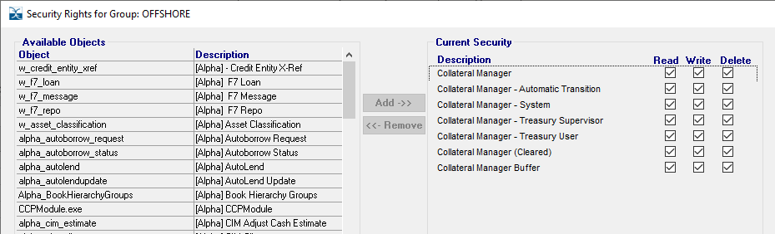
The objects can represent different components or modules within the system and provides the business with greater control.
The following is a list of CMS objects.

# | Object | Object Definition | Type
1 | Collateral Manager | Access to the Collateral Manager (CMS) | Module
2 | Collateral Manager (Cleared) | Access to the business line of ‘Cleared’ | Component
3 | Collateral Manager Buffer | Access to the Buffer static of the agreements | Component
4 | Cleared ASM Entry | Access to the ASM and launches via CMS | Module
5 | Collateral Manager Treasury User | Access to the standard workflow tools | Component
6 | Collateral Manager Treasury Supervisor | Access to the approval functions | Component
7 | Collateral Manager System | Access to the server user | Component
8 | Collateral Manager Automatic Transition | Access to the server user | Component
The following is a list of available states per object.

# | Rights | Description
1 | Unassigned | The object has not been assigned to the group and as a result the user will not have access to the component/module
2 | Read | The user can access the component/module on a ‘read only’ basis
3 | Write | The user can access the component/module, make actions/add data etc. When Write is selected then Read should also be chosen.
4 | Delete | Only applicable for static data, when selected the user will be able to delete static. When Delete is selected then Write and Read should also be chosen.
For a more detailed understanding please refer to the User Access FAQ.

How do I setup client and CCP data?
Client data is needed in SFCM to set up relationships and store critical data prior to creating collateral agreements in the CMS.
There is a range of client data needed and this section will cover all attributes so users can get the most out of the CMS.

Can I categorise different types of clients?
A Client Type is used to differentiate between the different market participants. For example CCPs and pension funds etc.
Select Administration>Static Maintenance>Clients>Client Types and add a new row for each client or counterparty you need. The following example shows both a client type for the CCP and client to help distinguish them.

Name | Type | Description
Code | Mandatory | Set a 2 digit code to identify the type
Name | Mandatory | The name of the client type
Relationship | Mandatory | The options are Internal or External.  Internal – if there are NO delivery details required for the given type.  External – if there are delivery details require for the given type

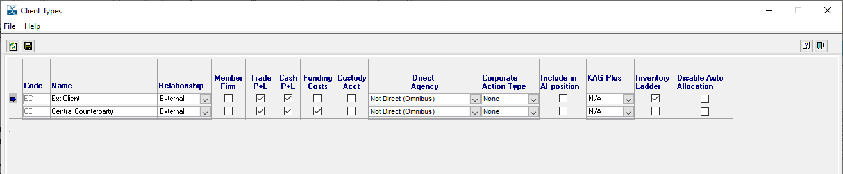

Can I add an external reference to the client data?
Client data may have an external code, this means an external code to SFCM. You can create unlimited amount of Client Code Types, these are known as Xrefs and can be added to the client data.
The code may be internal or external to the company but feeding in data to SFCM may source a different client code, in this case the Xref acts as a mapping to successfully feed in external data.

Name | Type | Description
Client Code Type | Mandatory | The code used for the Xref
Code Name | Mandatory | Full description of the Xref
Search Priority | Mandatory | The search priority when Xref searches are available

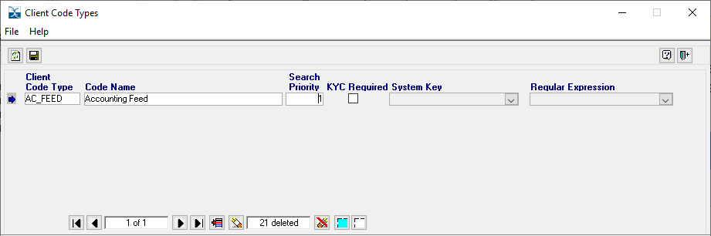
When setting up the client data you can add the Xref from the Details option.

Can I group client data in a fund major/minor setup?
In a similar way to the Profit Centre Management the Parent Client/Client structure allows you to group entities together in a fund major/minor hierarchy.
All client data requires a Parent Client, in some cases you may have the same Parent Client as the Client.
Select Administration>Static Maintenance>Client and Parent Clients from the menu.

Name | Type | Description
Code | Mandatory | The code of the Parent Client
Name | Mandatory | The name of the Parent Client
Company Code | Mandatory | The company code of the Parent Client. When there is more than one company then it is important to select the correct one.

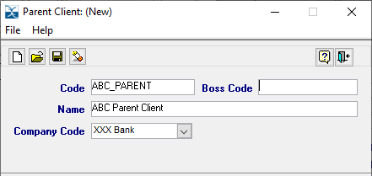

How do I setup client data?
Client data is used in all different areas of SFCM and therefore crucial in setting up correctly before proceeding into the CMS
Select Administration>Static Maintenance>Client and Client/Counterparty from the menu.

Name | Type | Description
Company | Mandatory | The company code of the client. When creating sub-companies then all collateral agreement related client data must be created under the same company.
Parent | Mandatory | The Parent Client for the client data and both Parent Client and Client must be under the same company.
Client Code | Mandatory | The code of the client or CCP
Client Name | Mandatory | The name of the client or CCP
Counterparty Type | Mandatory | The type of client
Country | Mandatory | The location of the client or CCP
Track Position | Optional | A tracking book needs to be created and linked to the client posting collateral.  For the purpose of client clearing a tracking client is needed (see section 3.3 profit centre management). In the event the clearing broker is feeding in client positions this will be the book the positions are loaded into to view external availability.  CCP’s are not created as tracking clients because they are represented as the counterparty in the module. Track Position is not applicable.
Status | Mandatory | Defines the status of the client and whether trading is permitted; Enabled, Restricted and Disabled.

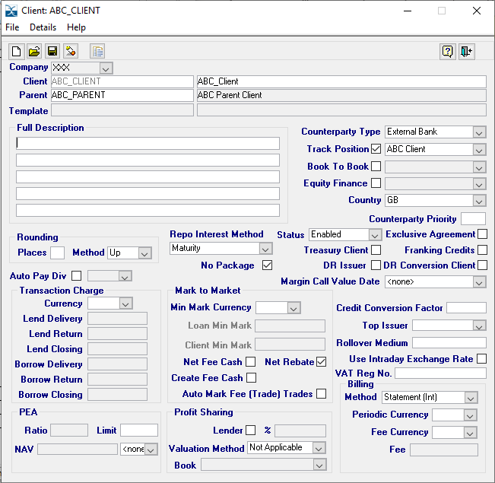
There is additional client data required to support the CMS, select Details from the menu for more options.

How do I set the rate on the bank loans for client financing?
The client Defaults is used for specifying rates on bank loans at the client data level. As described bank loans can be created automatically following the feed of an intraday call file, a bank loan rate must be specified for this to be successful.
Select Details and Defaults from the client menu.
The bank loan rate can be added at the client level.
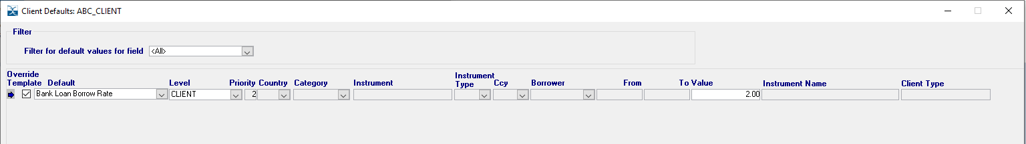
The bank loan rate can alternatively be added at the currency and client level.
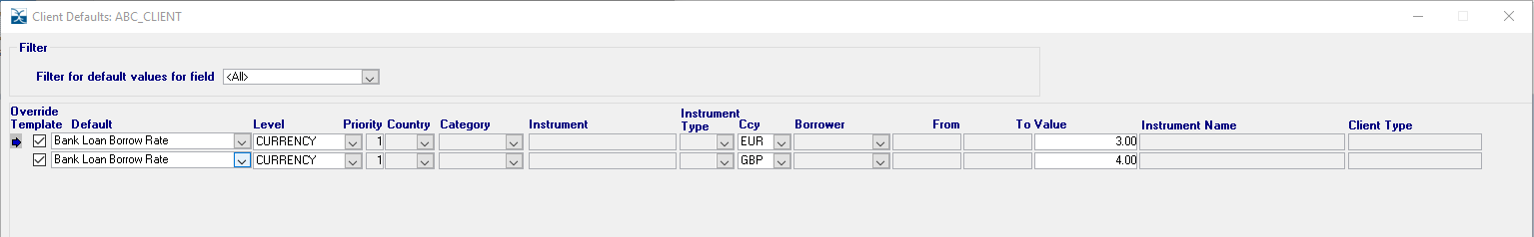

What additional static is needed for financing client intraday calls?
The client Agreement window represents the Master Agreement level, for this purpose a GMRA agreement type must be created before the bank loans can be created following a feed of intraday call files.
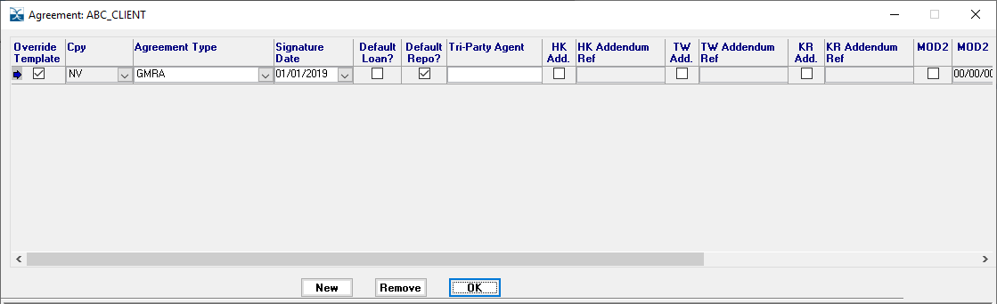

How do I set the SSI’s for the delivery of cash and non-cash collateral?
When setting up bank account and depot see Swift FAQ.
Agent Selection Weightings, Depot Selection Criteria and Bank Selection Criteria can also be found in the Swift FAQ.
Note: the bank and depot selection can be setup for IM and VM. 2 new trade types are introduced for defaulting the SSI’s in the event there are different accounts to pay/receive IM and VM at both the client and clearing member firm.

What additional CCP static data is required?
A CCP must be created before an agreement can be setup, this is in addition to the CCP being added to the client static data. The CCP is used to map the inbound files with the correct collateral agreement that will then populate the margin calls with the relevant CCP data.
The creation of the CCP within the collateral agreements are supported at the implementation stages and data will be seeded.
The CCP can be inserted via a script:
insert into al_cm_agreement_ccp (cm_agreement_ccp_id, ccp_code, ccp_desc, update_version, record_function)
values (al_seq_sdm_csapccp_id.NEXTVAL, 'CCP', 'CCP name', 1, 'SEED');

How do I assign clients to different regions or groups?

Select Administration>Client Groups from the menu.
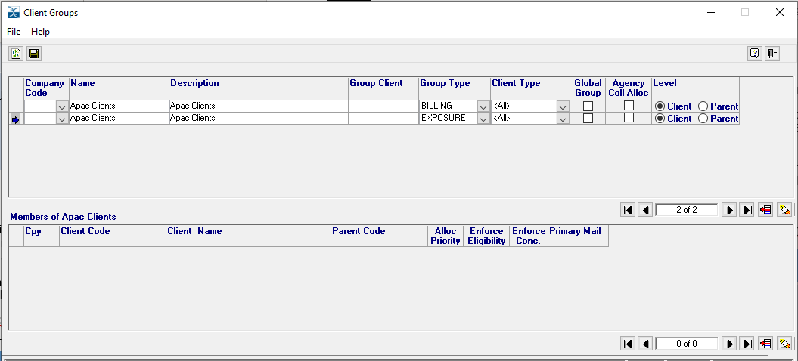

How do I setup the collateral eligibility and haircut static?
Please refer to the Xpose Static Data FAQ

How does the module automate the authorisation of certain trade types?
The Trade Authorisation window can provide the interfacing required for trades to be set with authorisation on selected trade types. The feature removes the need for manual intervention and can result in an automated solution for end users.
All trades created within SFCM have the capabilities to interface to a medium code that has been created in the Trade Authorisation window. In terms of the CMS, mediums codes have been created to support the flows of the client clearing activities.
The following table are the medium codes implemented to support the client clearing activities.

Medium Code | Description
OTCCLEARED | Non-cash collateral is created as matched collateral, this is where there are 2 collateral legs mirroring the movements in the market.  The inbound leg must settle before the outbound leg is released and the medium code interfaces to support the flows of the clearing broker. The outbound leg is auto authorised once the inbound has settled and consequently releases the swift message.
AUTOS | Trades created in SFCM are done so with an unverified status and typically requires a user to approve the trade. In some cases a trade does not need user approval and therefore can interface to the medium code. For example, bank loans (INTRADAYBL) and cash adjustments interface to the AUTOS medium code to auto verify and auto settle as there is no actual movement of assets to take place.
NOINSTR | Trades created in SFCM will have a default delivery setting, in some cases needs to be overridden. Different trade types will interface with the NOINSTR medium code, and in the case of client clearing both the bank loans (INTRADAYBL) and cash adjustments.
INTRADAYBL | Bank loans are created from the intraday feed and as there is no physical movement of assets the bank loans are auto verified and auto settled. In addition the medium code interfaces with the NOINSTR medium code.
Select Administration>Static Data Module and you will find Trade Authorisation from the menu.
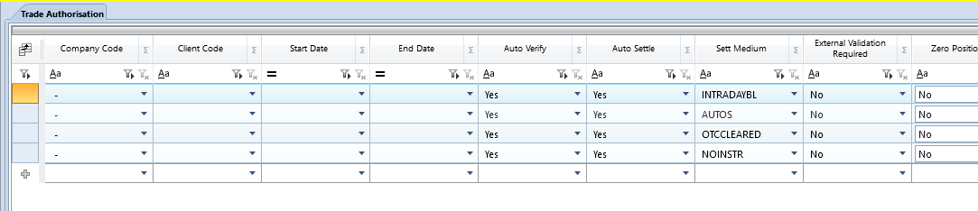

Why do I need an Agreement Type?
The Agreement Type window defines the type of collateral agreement and therefore determines the workflow the agreement will follow.
There is additional static required to complete the record such as the sender email address for when communication via email from the workflows.

Column Name | Description
Agreement Type | The type of collateral agreement.
Description | Add a description to provide more context to the record.
Business Line | Define the business line of the trading activity.
Clearing Method | Applicable only where business line is cleared and defines the relationship.  For the purpose of supporting the client clearing workflows set the clearing method to Client Clearing.
Client Clearing Type | Applicable only where the clearing method is client clearing, this defines the account set up at the CCP.
Collateral Sender | This is additional static to support the emailing of reports from the workflow, for this purpose reports are emailed to the clients.  The collateral sender in the case of client clearing will be the collateral desk at the clearing member firm.
Interest Statement Sender | Not applicable to client clearing collateral.

The Agreement Type window can be found in the Collateral Manager executable Middle/Back Office>Collateral Maintenance>Collateral Manager
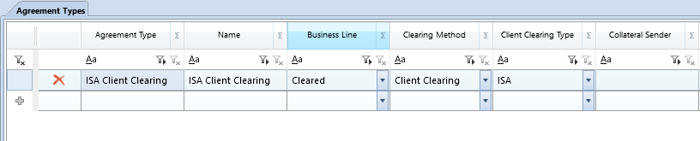

Can I edit an Agreement Type?
Yes, the only fields editable is the description and collateral sender. Any changes to other fields will result in the record needing deleted and re-added.

Can I delete an Agreement Type?
Yes, an agreement type can be deleted, but only where it has not been added to a collateral agreement.

Can I store multiple collateral sender email addresses?
No, the purpose of the collateral sender email address is to mirror the user of the workflow. This would typically be the group address of the collateral desk at the clearing member firm.

How do I setup new collateral agreements?
The agreements window defines the legal terms and the workflow configurations required to support the daily processes of margin calls.
It is important to note, only once the Clearing Account has been added to the agreements will the associated margin calls enter the workflow groups.
Before we can setup an agreement in the Collateral Manager we need to setup a few things in the main SFCM static first, so please go back to the start of 3.5.

Column Name | Description
Agmt Id | System generated id to identify the collateral agreement.
Agreement Type | The type of collateral agreement to be applied to the record.  This is one of the unique pieces of data that checks for duplication.
Agreement Name | A description added to the collateral agreement to help identify from others.  This is one of the unique pieces of data that checks for duplication.
Company Code | The top-level hierarchy and company of the collateral agreement.  This is one of the unique pieces of data that checks for duplication.
Principal | The entity for the purpose of client clearing will be the client of the clearing member firm.  This is one of the unique pieces of data that checks for duplication.
Counterparty | The entity for the purpose of client clearing will be the CCP/exchange clearing the trades.  This is one of the unique pieces of data that checks for duplication.
Status | The status of the collateral agreement and margin calls are only created when at active status.  Margin calls with outstanding cash and non-cash collateral will continue to be available in the workflows until returned.
Start Date | The start date of the legal agreement.
End Date | Where applicable the date the agreement ended.
Collateral Schedule | The schedules are created in the Xpose menu and linked to the collateral agreement.  See Xpose static FAQ for details
Agmt Ccy | The chosen currency to margin the IM exposure. The CCP’s may report the IM required in a different currency to the client preferred currency.
Rounding Method | Rounding methodology applied to the calculation of initial margin calls.  Options are Up/Down or Nearest.
Rounding Amount | The rounding value applied to the calculation of initial margin calls.
Call Start Date | The date from when margin calls can enter the workflows, this may be a future date.
Cash Settlement | The settlement default applied to the cash candidate bookings.
Bond Settlement | The bond settlement default applied to the collateral candidate bookings.
Equity Settlement | The equity settlement default applied to the collateral candidate bookings.
Trading Book | The trading book created against the clearing member firm (company).
Internal Comments | Comments the user can store on the agreement record.
Contacts | Stores the email addresses of the recipients for the client reporting.
Clearing | The static maps the clearing account number to the collateral agreements. When feeding in CCP data through the gateway the data can be assigned to the correct margin calls.  In addition there is an option for sub-accounts to be added for VM.
Buffer Static | Static to add CCP Buffer to the IM required that will increase the Net Exposure value applied to the margin calculation.  Broker Buffer is not currently applicable.

The Agreements window can be found in the Collateral Manager executable Middle/Back Office>Collateral Maintenance>Collateral Manager

Can I store multiple client email addresses?
As described earlier, you can store email addresses under the Contacts child window of the agreements window. Where you need to add multiple email addresses these should be separated using a semicolon between email address.
For example, noreply1@broadridge.com; noreply2@broadridge.com; noreply3@broadridge.com

How do I approve static data?
Please refer to the Static Authorisation Module FAQ

Can I view the audit of static data entries?
Please refer to the Static Data Auditing FAQ

Workflow

How is the margin call calculated in the Cash Calls group?

The margin call value displayed to the user to the

MC = Net Exposure (IM Required + CCP Buffer) – Cash Balance – Non-Cash Balance (not past 0 for non-cash)

How is the margin call calculation in the Intraday group?

The margin call value is displayed in the exposure grid of the workflow and is the same currency and value that was loaded from the CCP file. The system does not do any calculation or conversion for the intraday margin call, the function is to report the margin shortfall at the CCP.

How does the workflow manage multiple intraday margin calls?

The CCP’s calculate margin shortfalls through the business day and as a result there may be several for each client.

The workflow will display each intraday margin call reported by the CCP and as a result there is no summation of the margin calls.

Which FX rates are used in the workflow?
As long as CCP fx rates have been provided to SFCM these will be used to calculation the margin call requirements, this includes detailed data such as the CCP Breakdown window, Open Loans column and reporting margin call statements to clients.
During the booking process the SFCM fx rates are used to report the cash or non-cash collateral booked in the workflows. This will include the summary windows associated to the booking process.

How are the bank loans cancelled?

In the event the client has been able to make payment to cover the intraday margin shortfall the user can go into the bank loan and manually cancel. This will result in the bank loan no longer reported in the margin statements or Open Loan column.

  - For bank loan to be created ensure ‘Bank Loan Borrow Rate’ under client defaults have a rate applied (per Client or Client Currency) and delivery details are set up and weightings applied. SAM approved.
  - Email contact on agreement to email the report.
  - Bank loans are manually cancelled when client user story have paid ABN cash.
  - al_agreement

CCP Batch Monitor - select * from AL_CM_CCP_FILE_MONITOR order by batch_id desc, insert_date desc;

The records are coming from al_repo and using the end cash value to sum up all the open bank loans where the agreement id matches.

-Checking issues on creating bank loans from ICF's.
select r.processed, r.error_narrative, r.*FROM al_ext_repo r ORDER BY r.batch_id DESC;

ICF static and include emails etc (email sender/receipient on Agreement Type and Agreements.
DTL working (does it need restarting?), INTRADAYBL and AUTOS (this is for auto verifying and settling the bank loans) medium codes and have they been approved in SAM?
If the bank loans are not settled then the margin call statement does not get sent.

ASM – Inventory number of days is required for ASM to work.

Can only post cash in the convention specified on the currency static i.e. JPY cannot post 100.05, only whole numbers.

-Objects
-What is the NCC Excess/Deficit calculation/explanation

-Intraday
the flows around feeding in a ICF>bankloan>email to client

End of Document

